Installing Q-Radar

1) download qradar installation file

https://www.ibm.com/community/qradar/ce/

2) the downloaded file is a ova file which can be loaded to oracle vm

more detail for installation is available in following link

https://www.ibm.com/community/qradar/wp-content/uploads/sites/5/2020/11/b_qradar_community_edition_7.3.3GA_v1.0.pdf

3) access the qradar console

https://192.168.0.117/console/logon.jsp

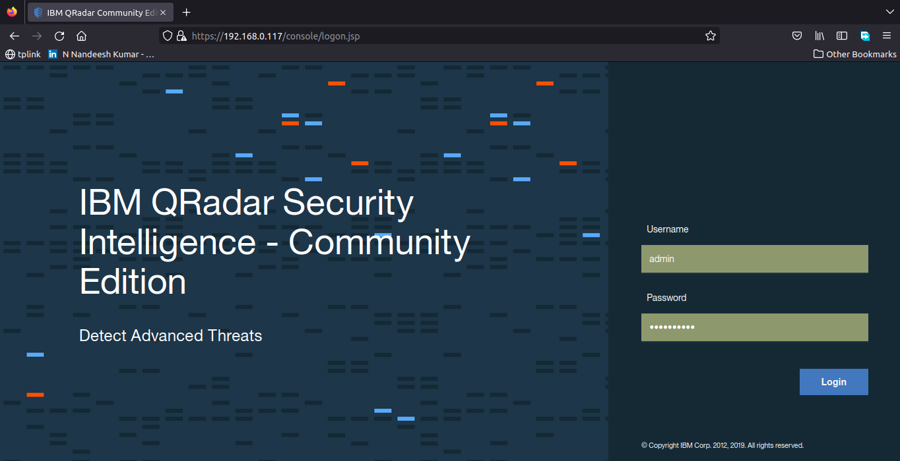

4) the qradar menus are available to access

